**Monthly Newsletter Content November 2024**

Theme: Prayer for the Deceased; Purgatory

**Faith in Action Calendar / Highlights**

Sunday, November 10 – St. Leo the Great, Pope

Saturday, November 23 – Blessed Miguel Augustin Pro, Priest and Martyr

Sunday, November 24 – SOLEMNITY OF CHRIST THE KING

**Page Content**

**Monthly Synopsis:**

**November 2024** – Catholics believe in the reality of purification after death, which we call Purgatory. We take it as a serious obligation to pray for the deceased who have gone before us. This is the Church’s liturgical focus in November. We live with confident hope that those who die in Christ will one day experience the grace of the Resurrection, which is our hope too!

**Backgrounder:**

**Prayer for the Deceased**

Following the feast of All Saints on November 1st each year, we celebrate All Souls Day on November 2nd, where we pray for those whom the Church calls the “holy souls”. In this, we recognize that the souls of the deceased *have already been saved*. They are “holy souls” in the sense that they belong to Christ and are assured of the promise of Heaven.

The Catholic belief in Purgatory is an ancient doctrine that has its roots in the Jewish *Haggadah*, the mourning prayers for the dead. Based on the Second Book of Maccabees (Chapter 12), the Jews believe that it is possible to atone for sin after death, and that the faithful can assist the deceased with their prayers. Catholics too believe this scriptural teaching.

Since the Middle Ages, All Souls Day has been a universal feast of the Church and is the only day on which a priest may celebrate three Masses without need for special permission. On All Souls Day, priests offer Masses for *all* the souls in Purgatory. In many traditionally Catholic societies, the faithful also make visits to cemeteries to visit the graves of their deceased loved ones on this day.

Prayers for our dearly departed are not reserved to the Mass, though. We may – and should – pray regularly for all souls who have died and are still undergoing purification in Purgatory. For this reason, the Church has given us a beautiful prayer to remember the souls in Purgatory and to assist them in obtaining the light of Heaven.

This prayer is often prayed in conjunction with the prayer before meals, although it can be prayed at any time by the faithful:

*Eternal rest grant unto them, O Lord,*

*and let perpetual light shine upon them.*

*May the souls of the faithful departed,*

*through the mercy of God, rest in peace. Amen.*

As we pray this prayer, it would be good to remember that someday we too will meet our final end, and we will want our loved ones and the whole Church praying for us!

**Spiritual Challenge:**

Our challenge in November is to pray for all of our deceased loved ones and their ultimate reunion with God in heaven. Let us also remember those who have died in tragedies and natural disasters around the world. An even greater challenge than these is to pray for the souls of those who were our enemies.

**Bible Basics:**

**2 Maccabees 12:43-46**

“[Judas Maccabeus] then took up a collection among all his soldiers, amounting to two thousand silver drachmas, which he sent to Jerusalem to provide for an expiatory sacrifice. In doing this he acted in a very excellent and noble way, inasmuch as he had the resurrection in mind; for if he were not expecting the fallen to rise again, it would have been superfluous and foolish to pray for the dead. ... Thus he made atonement for the dead that they might be absolved from their sin.”

**Faith Fundamentals:**

**The Doctrine of Purgatory**

One of the most misunderstood teachings of the Church – even among Catholics – is the doctrine of Purgatory. But let’s be sure not to complicate matters which the Church explains very simply.

There are only three short paragraphs in the *Catechism of the Catholic Church* needed to explain the core teaching of the Church on this subject. They can be summarized in three brief points:

1. That most souls, except the holiest, must undergo some form of spiritual purification after death;
2. That this purification is painful but also full of the hope of Heaven; and
3. That the prayers, sacrifices and supplications of the living assist those who are being purified in Purgatory.

This is the whole of the teaching, which reminds us how important it is to pray for those who have gone before us.

**Catechism Connection:**

**1031** – The Church gives the name Purgatory to this final purification of the elect, which is entirely different from the punishment of the damned. The tradition of the Church, by reference to certain texts of Scripture, speaks of a cleansing fire: As for certain lesser faults, we must believe that, before the Final Judgment, there is a purifying fire.

**1032** – From the beginning the Church has honored the memory of the dead and offered prayers in suffrage for them, above all the Eucharistic sacrifice, so that, thus purified, they may attain the beatific vision of God. The Church also commends almsgiving, indulgences, and works of penance undertaken on behalf of the dead.

**School of the Saints:**

“Let us help and commemorate them. If Job’s sons were purified by their father’s sacrifice (Job 1:5), why would we doubt that our offerings for the dead bring them some consolation? Let us not hesitate to help those who have died and to offer our prayers for them.” ~ St. John Chrysostom

“If only you knew with what great longing these holy souls yearn for relief from their suffering. Ingratitude has never entered Heaven.” ~ St. Margaret Mary Alocoque

***Back to Basics* Featured Prayer:**

**Prayer for Final Perseverance**

Oh Jesus, my Savior, my God, by Your Sacred Heart, by the most pure Heart of the virgin Mother, by whatever is pleasing to you in heaven and on earth, I beg and entreat you, grant me holy perseverance, grant me patience. Give me grace and courage that I may efficaciously employ the means which you have given for the salvation of my soul. Amen.

(This prayer is taken from the Prayers in the Pew *All Souls Edition* Prayer Card. Please refer to our website SitStandKneel.com for the online version of this newsletter and all our prayer cards.)

**Calendar of Faith for November:**

11/1 – SOLEMNITY OF ALL SAINTS

11/2 – All Souls Day

11/3 – St. Martin de Porres, Religious

11/4 – St. Charles Borromeo, Bishop

11/9 – Dedication of St. John Lateran Church

11/10 – St. Leo the Great, Pope

11/11 – St. Martin of Tours, Bishop

11/12 – St. Josaphat, Bishop and Martyr

11/13 – St. Francis Xavier Cabrini, Virgin

11/15 – St. Albert the Great, Bishop and Doctor

11/16 – St. Margaret of Scotland

11/17 – St. Elizabeth of Hungary, Religious

11/18 – St. Rose Philippine Duchesne, Virgin

11/21 – Presentation of Mary

11/22 – St. Cecilia, Virgin and Martyr

11/23 – Blessed Miguel Augustin Pro, Priest and Martyr

11/24 – Sts. Andrew Dung-Lac and companions, the Vietnamese Martyrs

11/24 – SOLEMNITY OF CHRIST THE KING

11/25 – St. Catherine of Alexandria, Virgin and Martyr

11/30 – St. Andrew, Apostle

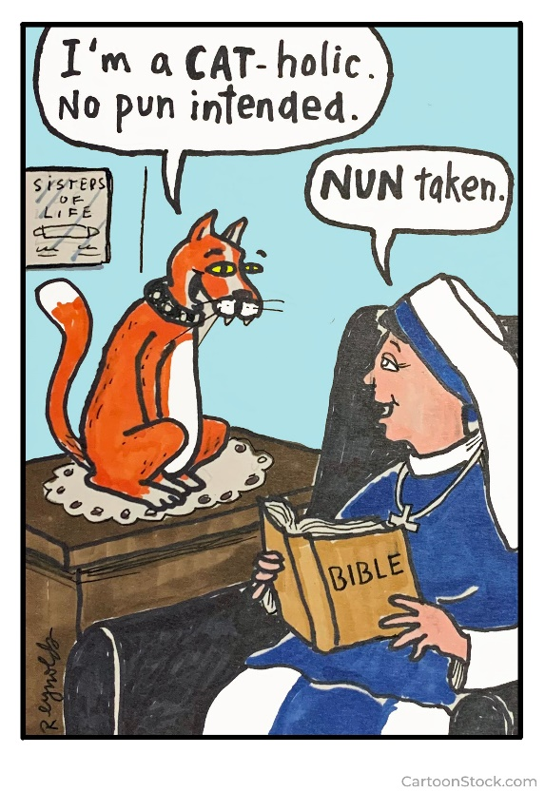

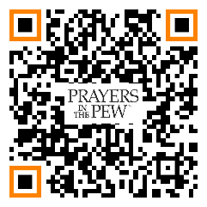

The *Prayers in the Pew* monthly newsletter and *Faith Fundamentals* supplement are publications of SitStandKneel Partners, San Diego, CA. Visit us at wws.sitstandkneel.com for our prayer cards, novenas, and online newsletters. See our special offer on Prayer Cards by using the QR Code.

*Helping Catholics to Learn, Live, and Love their Faith.*